 | MINISTRY OF EDUCATION AND TRAINING

FPT UNIVERSITY
Capstone Project Document
SCARA ROBOT
Group 5
Group Members | Lưu Việt Hoàng – Leader – 60458  Phùng Võ Hải Triều – Member – 60086  Bùi Thái Hòa – Member – 60470  Nguyễn Minh Phú – Member – 60456
Supervisor | Trần Khánh Ninh
Ext Supervisor
Capstone Project code | SCR

- Ho Chi Minh City, May/2013 -

PART B – SOFTWARE PROJECT MANAGEMENT PLAN

PROBLEM DEFINITION

NAME OF THIS CAPSTONE PROJECT
The official name of this project is “Scara-Robot”. The project code is “SCR”.

PROBLEM ABSTRACT
In many countries, the use of robots in industry is casual. However, the cost of robot’s importation is very high. Vietnam is a developing country. All we know that hard to make a perfect robot for application. This project of our team is a project to make a scara-robot which can use in application.

PROBLEM OVERVIEW

The Current Systems
Most of robot’s arms are based on available engine design. The part of perfect robot – controller – is Programmable logic controller (PLC) or Hydraulic. The PLC and Hydraulic are simple programming, easy controllers. However, the cost is very high. Furthermore, it needs synchronization of vendor’s devices.
Nowadays, many electric products such as: remote, printer, mobile, car, etc... Use microcontrollers. It does not only decrease the cost but also flexible processing. Microcontrollers are programmed to focus several important purposes, so they are higher performance. If we want to upgrade, we can replace another microcontroller easily because of compatible relative controllers.
Concluded that, with microcontroller, we save time, cost for device. For research and study, the microcontrollers are also appropriate in our country at this time.

The Proposed System
The system applies the advantages of Microcontroller (High operating frequency , active low power requirement , code reuse , code size reduction , flexible connectivity , ... ) to create one mediate application, enables to add a other application or a script, thereby indirectly controls the robot . Interface is easy to use. Compatible with many other systems using same a Microcontroller . The application also allows us to know the activities, as well as the position of hand machine , to make the most optimal solutions.

Boundaries of the System
Development whole of the system became a automatical robot. Can be programmed flexibly on multiple axis motion , describe their freedom level. Connect , controlled by computer software , repeat the order of the program, integrated set of programs on the 3D quadrants. Ability to locate , orient move physical objects by changing the command from software to perform various tasks. Maybe fit hand machine or any other equipment to perform certain tasks such as welding , cutting , drilling, …

Be sure to have :
- The legal hold , conversion optimization
- Ability to work flexible
- The structure must comply with the principle of modularity

Development Environment
Our team’s product will be the robot’s arm (scara-robot). This is developed with following hardware and software environment:
Hardware environment:
  - Robot’s arm engine with 6 levels motor.
  - 4 laptops with appropriate configuration for embedded development.
Software environment:
- Developing environment ARV studio 4 for main board programming.
- Developing environment Visual studio 2010 with C# language for user interface programming.

PROJECT ORGANIZATION

SOFTWARE PROCESS MODEL
SCRUM MODEL
The Waterfall method was not working well for our project and we decided to use Scrum as the framework to move over to the Agile process.

OVERVIEW DIAGRAM
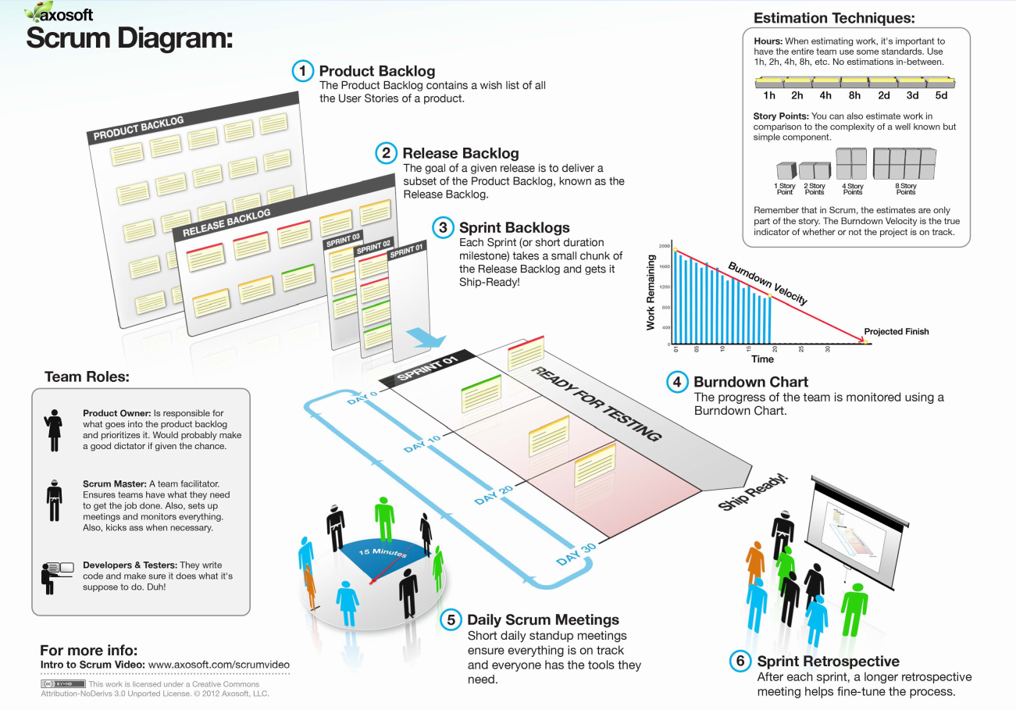

At first, we decided the sprint’s duration is about 2 week because of the project characteristics. At the beginning of one sprint, through sprint planning meeting, all team members will discuss to define sprint backlog which is suitable to be completed within 2 week. Daily meeting is not operated; instead we use daily report and online conference to manage all activities

ROLES AND RESPONSIBILITIES
No. | Full name | Team Role | Scrum Team Role | Responsibilities
1 | Trần Khánh Ninh | Supervisor | Stake Holder | - Define business  - Support in technical issues
1 | Lưu Việt Hoàng | Team Leader | Product Owner, Scrum Master | - Outline work in scrum backlog  - Prioritize work  - Answer question and deliver direction  - Facilitate productivity – maximize team performance  - Complete all individual work
3. | Phùng Võ Hải Triều | Team Member | Scrum Team Member | - Commit individual product on time  - Support each other to complete team work
4 | Bùi Thái Hòa | Team Member | Scrum Team Member | - Commit individual product on time  - Support each other to complete team work
5 | Nguyễn Minh Phú | Team Member | Scrum Team Member | - Commit individual product on time  - Support each other to complete team work
Supervisor act like the role of customer and get access to all the activities of the team, support in resolve issues and problem occur during the implementation of Sprint.
Team leader is also Product Owner, who supports the whole team by outlining work in the scrum backlog, prioritizing it and being available to answer questions and deliver direction.
Scrum Master has responsibility to do everything she can to facilitate productivity – address the needs of the team and help Product Owner to maximize team performance. As a real team player, she also is required to complete all individual work.
Scrum Team is expected to be self-organized, cross-functional with high adaptability. All members have the right to do anything within the boundaries of project to reach the sprint goals and also have responsibility not only to commit their individual product on time but also to support each other to ensure team can complete its work.
There are no fixed term for Team members – depend on time and demand of project, a member can play role of software architect, programmer, analyst, QA expert, tester, UI designers, etc.

TOOLS AND TECHNIQUES

For Development
Hardware environment:
  - Robot’s arm engine with 6 levels motor.
  - 4 laptops with appropriate configuration for embedded development.
Software environment:
- Developing environment ARV studio 4 for main board programming.
- Developing environment Visual studio 2010 with C# language for user interface programming.

For Management
- Microsoft Project: Task tracking
- Tortoise SVN: Source version control
- Google Code: Connect, synchronize source code and documents
- Beyond Compare: Manage changes in source files

For Communication
- Gmail for daily report and meeting minute
- Skype chat system

PROJECT MANAGEMENT PLAN

TASKS
At the beginning of each sprint (Sprint Planning Meeting), based on Product Backlog and discussion with Project Owner, team will together put all the prioritized tasks to be assigned and create Sprint backlog document. This document also is task list for each sprint.
Product Backlog and Sprint Task List can be found at:

https://subversion.assembla.com/svn/scara_capstone/trunk/WIP/Documents/Members/HoangLV/Capstone_Group5_ProductBackLog_SprintTaskList.xlsx

Product Backlog

DOCUMENTATION
As a SE, I expect to have all related documents to be delivered on time. Those documents are separated into 6 reports, include:
REPORT NO. | DESCRIPTION | DELIVERY DATE
1 | Introduction | 2012.05.20
2 | Software Project Management Plan (SPM) | 2012.05.27
2 | Problem Definition
2 | Project organization
2 | Project management plan
2 | Coding convention
3 | Software Requirements Specifications (SRS) | 2012.06.08
3 | User Requirement Specification
3 | System Requirement Specification (Specific Requirements)
3 | External Interface Requirements
3 | System Features
3 | Use Case Diagram & Use Case Specification
3 | Software System Attributes
3 | Entity Relationship Diagram
4 | Software Design Description (SDD) | 2012.06.22
4 | Design Overview
4 | System Architectural Design
4 | Component Diagram
4 | Detailed Description of Components
4 | Sequence Diagram
4 | User Interface Design
4 | Database Design
5 | Software Test Documentation (STD) | 2012.07.22
5 | Test Plan
5 | Test Cases
5 | Checklists
6 | Software User’s Manual (SUM) | 2012.08.19
6 | Installation Guide
6 | User’s Guide
FINAL | Completed version of Report No.1 to Report No.6 – Soft copy | 2012.08.20
FINAL | Completed version of Report No.1 to Report No.6 – Hard copy | 2012.08.20

IMPLEMENTATION
As Product Owner, I expect to have the CDs contain all source code and deployable ScaraRobot Arm at the end of project
Application must be developed and tested completely. Those feature need to be implemented:
MODULE | DESCRIPTION | DELIVERY DATE
Scara’s Robot arm
0 | Built on Scara Robot’s arm PLC
1 | Design board & Write controller Code
1 | Control Hardware
1 | Get sensors value
1 | Get Feedback from sensors
1 | Create Spec message definition
2 | C# Control
2 | UI
2 | Interact & send message through RS-232
3 | Move definition motor values to positions
3 | To be broken down
4 | Demo with Hanoi Tower problem
4 | Algorithm
4 | Control code
4 | Timing on callback
Final | CDs contain all source code and deployable Scara Robot Arm as final version | 2012.08.20

Master Schedule (Microsoft Project file) can be found at:

https://subversion.assembla.com/svn/scara_capstone/trunk/WIP/Documents/Members/HoangLV/ScaraRobotPlan.mpp

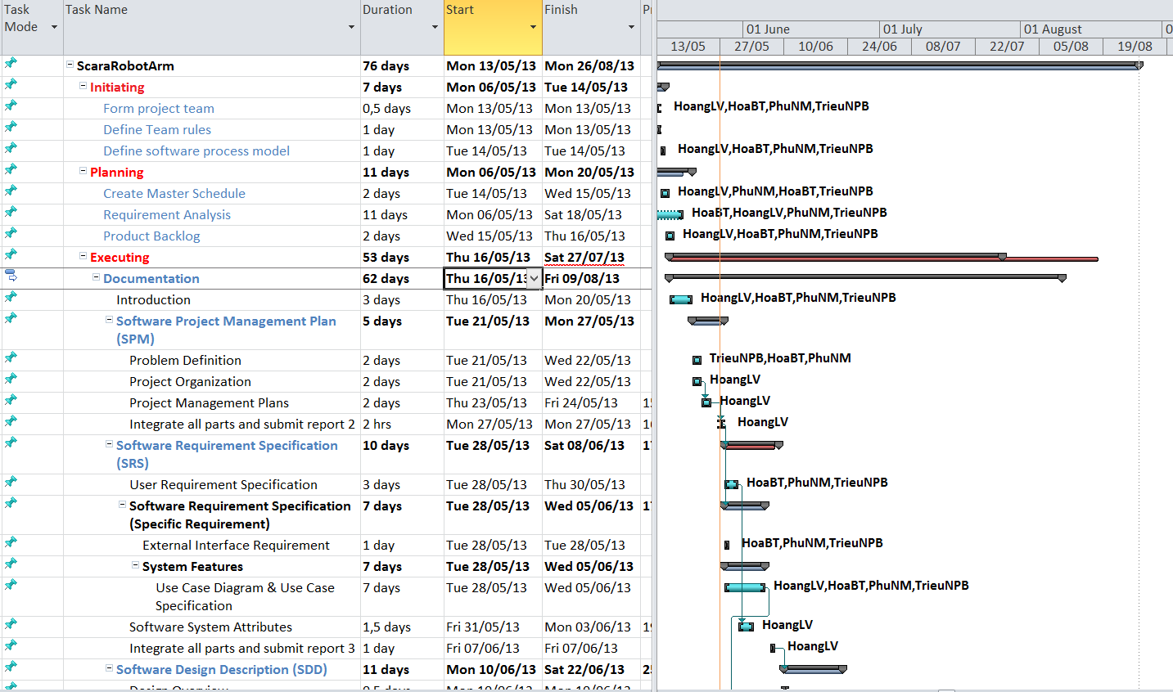
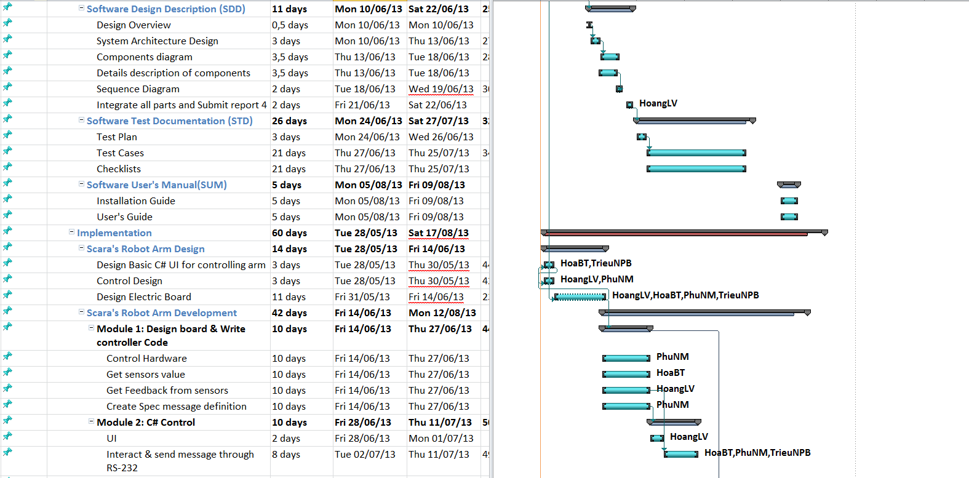
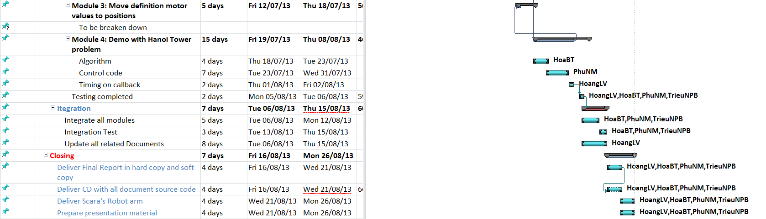

RISK ASSESSMENT
Risk assessment can be found at:
https://subversion.assembla.com/svn/scara_capstone/trunk/WIP/Documents/Members/HoangLV/ RiskAssessment.docx

DELIVERABLES
- No | Deliverable | Delivery date | Delivery location | Note
1 | Introduction Document | 2012.05.20 | FU – CMS | Report No.1
2 | Software Project Management Plan | 2012.05.27 | FU – CMS | Report No.2
3 | Software Requirements Specification | 2012.06.08 | FU – CMS | Report No.3
4 | Software Design Description | 2012.06.22 | FU – CMS | Report No.4
5 | Software Test Documentation | 2012.07.22 | FU – CMS | Report No.5
6 | Software User’s Manual | 2012.08.19 | FU – CMS | Report No.6
7 | Completed version of Report No.1 to Report No.6 – Soft copy | 2012.08.20 | Classroom  FU – CMS | Final version
8 | Completed version of Report No.1 to Report No.6 – Hard copy | 2012.08.20 | Classroom | Final version
9 | CD contains all Source code and installable system | 2012.08.20 | Classroom | Final version

* For each sprint, deliverables is potentially shippable product, which can be a part of documents or runnable software application which is implementation of some program features.

ALL MEETING MINUTES
All Meeting Minutes are put in folder
https://subversion.assembla.com/svn/scara_capstone/trunk/WIP/Documents/MeetingMinutes

CODING CONVENTION
Reference Coding Convention document can be found at: https://subversion.assembla.com/svn/scara_capstone/trunk/WIP/Documents/CodingConvention.pdf

